Designing the “Saathi Community Clinic” Health Information System: A Tele-Enabled, Interoperable Framework for a University Town Clinic

Yogesh Palikhe, Maazkhan Riyazkhan Pathan, Gayatri Polu, Menaka Reddy Mukkala,
EUID: yp0401,mp1616, gp0432, mm3282

Department of Information Science, College of Information, University of North Texas
HINF 5365 Section 021 - Information Systems in Healthcare

Dr. Ana D. Cleveland, Ph.D., A.H.I.P., F.M.L.A.

November 15, 2025

Clinic Overview
Saathi Community Clinic is a small, community-oriented health facility located in Denton, Texas. Saathi means "friend" in both Nepali and Hindi languages, reflecting the vision of the clinic to promote togetherness, well-being, and compassion in the community. It seeks to address the healthcare needs not only of local residents but also of the large student population from UNT and TWU.
The clinic serves an estimated 6,000 registered patients annually and an average of 50 to 60 patient visits per day. The peak flux of patient is usually in fall during the academic semesters when many students present for routine care, vaccinations, and mental health consults. The patient population served is primarily young adults from ages 18-35 years (60%). The healthcare provided at the clinic serves a culturally diverse demographic breakdown: approximately 40% Asian (including Nepalese, Indian, Chinese, Vietnamese), 35% Hispanic, and remaining ethnic groups (25%). The facility houses 8 exam rooms, one minor procedure room, one telehealth suite, and administrative offices.
The clinic has a total of 15 full-time staff: 3 physicians, 2 nurse practitioners, 4 nurses, 4 administrative staff, and 2 IT support specialists.

The services offered by Saathi community clinic include:
- General outpatient consultations and preventive care
- Immunizations and health screenings
- Minor urgent care and wound management
- Women’s health and reproductive services
- Chronic disease management (diabetes, hypertension, asthma, thyroid disorders)
- Behavioral and mental health counseling
- Telehealth/telemedicine for remote consultations and follow-ups along with after hours care
- Community outreach and wellness programs mainly focusing on students and under-served groups

Key Stakeholders

- Healthcare providers
It includes the people in the clinic who are responsible for providing medical care to incoming patients. They provide clinical documentation and enter orders into the HIS. It consists of physicians, nurse practitioners, and nurses.

- IT/Informatics Coordinator
The department is responsible for maintaining the HIS, ensuring interoperability, and monitoring and maintaining data integrity.

- Clinic Management/Leadership
The clinic management and leadership team oversee the clinic’s policy decisions, budget allocation and overall HIS effective functionality. They work to align the system with the clinic’s goals, streamline workflows and ensure compliance with regulatory requirements.

- Administrative Staff
The administrative staff handle the day-to-day administrative tasks of the clinic which includes and are not limited to handling schedules, billing and records.

- Patients
Patients use the HIS through the patient portals, telehealth services and remote monitoring tools such as lab results to manage their health information and communicate with healthcare providers.

- External Labs & Pharmacies
External labs and pharmacies receive and transmit electronic orders and test results using the HIS which ensures an efficient coordination of patient care.

- Payers (Insurance/Student health plans)
Payers include insurance companies and student health plans which uses the HIS for claims submission, verification and reimbursement processes.

- Public Health Department
The clinic provides immunization records and reportable diseases through the HIS to the public health department to support in monitoring public health along with ensuring compliance with reporting regulations

System Design Proposal

The Sathi Community Clinic Health Information System is envisioned to be a centralized EHR-centric architecture with tightly integrated subsystems for scheduling, billing, laboratory, imaging/referral, telehealth, patient portal/remote monitoring, and interoperability with external systems. This will be cohesively designed with emphasis on workflow, robust interoperability, and scalability/security, rather than a number of isolated flashy modules.

The major Architecture Components in the clinic consists of:
- Central Electronic Health Record (EHR): The hub of the system. Stores patient demographics, problem lists, medications, allergies, notes, encounter history, orders (labs, imaging, referrals), results, billing codes, and telehealth session logs.
- Scheduling Module: Interfaces with EHR to offer booking of in-person visits, telehealth visits, nurse-triage slots, and chronic-care follow-ups. The scheduling system is aware of visit types (in-person vs telemedicine), resource (room, physician, equipment) and integrates with reminder/notification services (SMS/email).
- Billing & Claims Module: Integrated with EHR encounter data and coding (CPT/ICD/HCPCS). Automatically captures services rendered, links to payer eligibility, claims submission, and reconciliation with the clinic’s financial system. Also supports student health-plan billing and private pay.
- Lab/Imaging Integration: Orders created in EHR flow electronically to partner labs/imaging centers (via HL7/EDI interfaces) and results return automatically into the patient chart. Point-of-care tests performed in-clinic are captured and stored in the EHR results section.
- Telehealth Platform & Remote Monitoring Module: A dedicated subsystem tied to the EHR. Tele-visits are scheduled via the scheduling module, link to video session platform, and documentation is saved in the EHR. Patient remote monitoring (e.g., home BP monitors, glucose monitors) feed data via API, are stored in a “remote monitoring” repository, and flagged for care-team review if thresholds exceeded.
- Patient Portal / Mobile App: Enables patients to view their records, schedule visits (in-person or telehealth), pay bills, send secure messages, and access remote-monitoring data. Also supports telehealth sessions through the portal/app.
- Interoperability Module & Health Information Exchange (HIE) Interface: A middleware layer that manages data exchange with external systems—other clinics/hospitals, pharmacies, public health registries, payers, and labs. Conforms to standards (e.g., HL7 v2/v3, HL7 FHIR, CDA) and supports query/exchange services as well as push notifications (for example labs, immunization, medication history).
- Security/Privacy & Master Patient Index (MPI): A module that manages identity (unique patient identifiers within the clinic and matching external identifiers), role-based access control, audit logs, consent management (including telehealth consent, remote monitoring consent), encryption at rest and in transit, and compliance with U.S. regulations (HIPAA, 21st Century Cures Act).
- Analytics/Quality Module: Using structured data in the EHR (and remote monitoring), supports dashboards for quality measures (for example preventive screening rates, telehealth follow-up compliance), population health insights, and research support.
- Referral/Transitions of Care Module: Manages outbound referrals (with secure messaging) and inbound clinical documentation from external providers. Ensures communication of care transitions, summary care records, and discharge summaries.

System Architecture and Data Flow Diagram
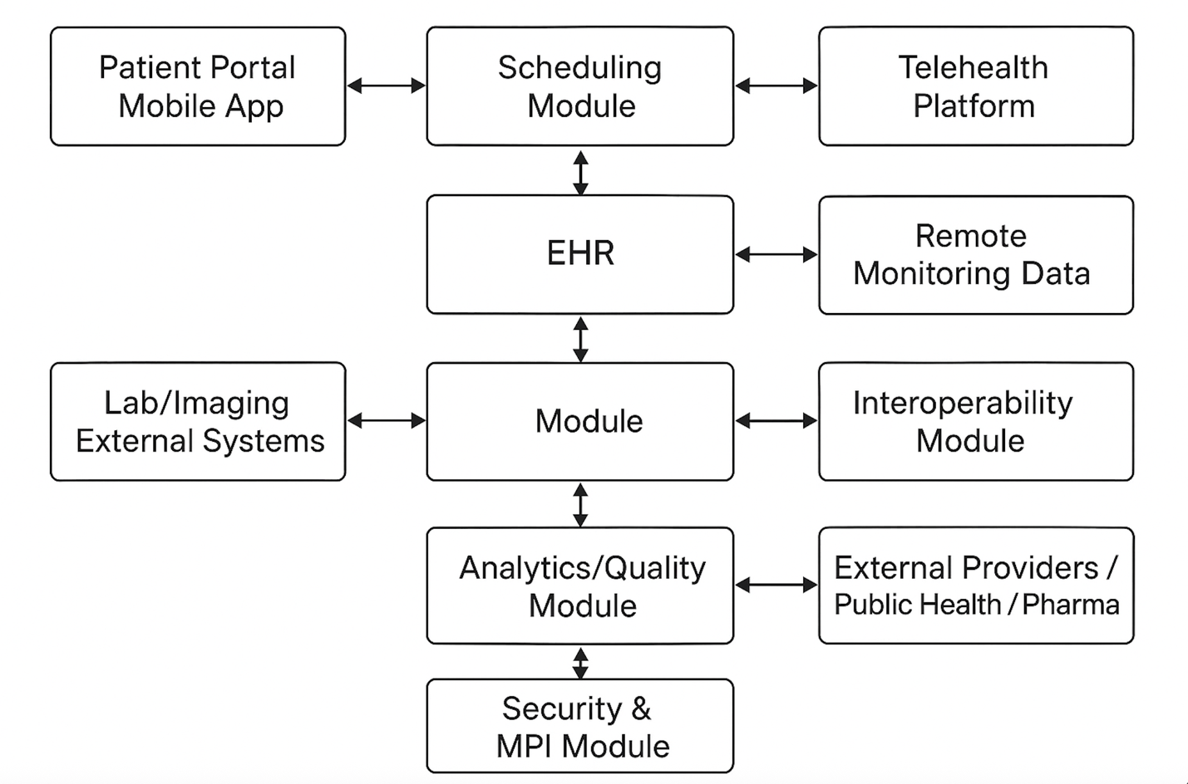

When the patient books a telehealth visit, data from the portal flows into the scheduling module to create an encounter within the EHR. During the session, clinicians document the care provided; in cases where lab tests are ordered, the interoperability module sends those orders to the external lab. Results return automatically, populating the patient record. Simultaneously, the billing system processes claims, and the analytics module tracks quality and performance data.
Because of this integration, a closed-loop information cycle is guaranteed-all contact with the patient, physical or virtual, falls within one interoperable framework.

Interoperability and Standards
Interoperability is the backbone of Sathi Clinic’s HIS. Following HIMSS definitions, interoperability allows systems to “access, exchange, integrate, and cooperatively use data across boundaries to optimize health outcomes” (Healthcare Information and Management Systems Society [HIMSS], 2024).
The system supports:
- Foundational interoperability: HL7 v2 interfaces for lab and imaging results.
- Structural interoperability: Consistent data syntax for scheduling and billing.
- Semantic interoperability: Use of standardized vocabularies (SNOMED-CT, LOINC, ICD-10).
- Organizational interoperability: Consent management, data governance, and secure data-sharing policies.
Research indicates that strong EHR interoperability reduces duplicate testing, enhances patient safety, and improves chronic disease management outcomes (Li et al., 2022; Perlin et al., 2016). By implementing HL7 FHIR APIs, the system ensures compatibility with pharmacies, public health registries, and regional HIEs. Studies have shown that FHIR-based systems improve data exchange efficiency by up to 40% compared to legacy systems (Benson & Grieve, 2021)

Integration of Telehealth and Remote Monitoring
Telehealth and remote monitoring are one of the key component of the HIS architecture of Sathi Community Clinic. This system was given priority considering the large student population in Denton and the convenience required to access health care services. Moving with healthcare trends, these features push healthcare beyond the confines of a physical clinic and promotes continuity, accessibility and efficiency. The components of the said systems are:
1. Telehealth Visits
Patients can log in through the patient portal or mobile app of the clinic to schedule video consultations. After the appointment is confirmed, the telehealth session takes place through a HIPAA-compliant video platform which is integrated directly into the Electronic Health Record. During the session, the physicians in the clinic can access the patient's chart, document notes, and update medical records in real time. This would be just as in an in-person visit. After the session is over, the system automatically forwards consultation details to the billing module, where telehealth visits are coded using proper modifiers for reimbursement accuracy.Doing this allows financial workflows to align with the requirements of payers for telemedicine.
2. Remote Patient Monitoring (RPM)
In the case of chronic conditions such as diabetes, hypertension, or asthma, medical devices integrated with Bluetooth such as glucometers, blood pressure cuffs, and pulse oximeters, send readings directly to the EHR via secure APIs. These devices communicate through patients' mobile apps that authenticate users and encrypt data transmission. If the readings cross preset thresholds as for example, very high blood glucose or blood pressure-the HIS generates real-time alerts automatically, notifying the nurse dashboard for clinical review. The nurse then may message the patient through the portal, schedule a teleconsultation, or escalate to a physician. This proactive approach greatly ensures adherence, safety, and early intervention.
3. Integrating Billing and Analytics
All telehealth encounters and remote monitoring activities are automatically linked to the billing system. The HIS differentiates between standard and telehealth visits using visit-type modifiers, ensuring accurate CPT and ICD-10 coding for reimbursement. The analytics module is constantly tracking telehealth utilization rates, patient satisfaction, waiting times, and compliance with follow-ups. These data feed into quality dashboards used by clinic administrators to find patterns, for example, if students prefer late-evening teleconsultations during exam weeks. This optimizes the administrative workflow of the clinic exponentially.
4. Impact on Care Continuity
Such integration increases access to services while enhancing continuity of care, especially in young, mobile populations such as students. There is evidence that telehealth-supported chronic care management results in significant improvement in medication adherence, monitoring compliance, and overall patient satisfaction.
Piecing all these components together form a closed-loop digital care system: patients, providers, and health data all connected in real time to ensure that no critical information falls through the cracks between appointments or devices meanwhile actively working on reducing errors and optimize care delivery. Such systems have been shown to improve continuity of care and adherence in chronic disease patients (Choi et al., 2023). Furthermore, the integration of telehealth has proven to expand access and reduce appointment no-shows by 30% in similar community clinics (Kichloo et al., 2020).

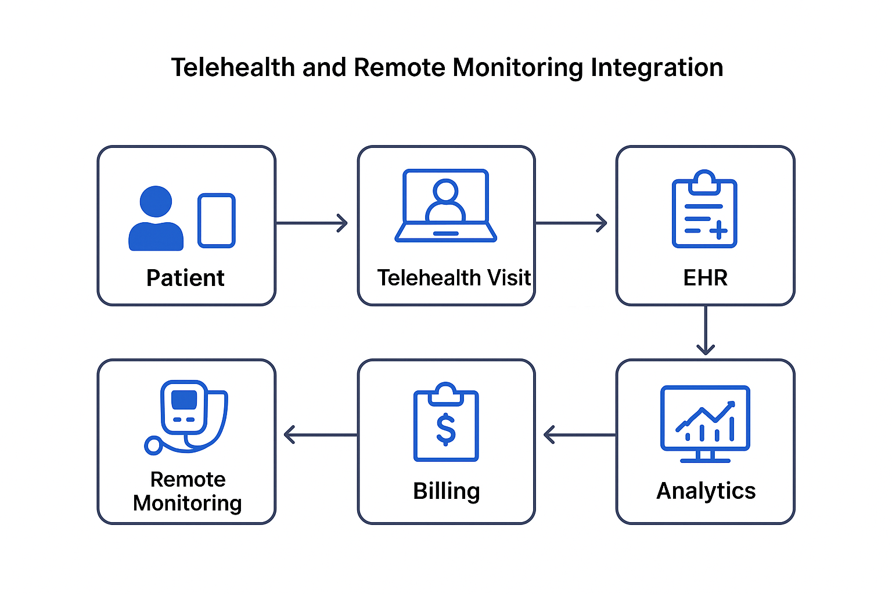
The key metrics of the system and successful acheivement of clinic goals would be determined on the basis of following things:
- Approx. 20% of total visits via telehealth in Year 1 of operation.
- <10% telehealth no-show rate.
- 90% success rate for external data exchanges
- 30% of chronic-care patients enrolled in remote monitoring.
- Improved blood pressure and HbA1c control metrics follwing remote monitoring.

The Sathi Community Clinic HIS shows how a small, community-focused clinic can adopt a cohesive, interoperable, and patient-centered system that supports both traditional and telehealth services. Following HL7 FHIR standards and privacy-first architecture, it brings clinical, administrative, and technological needs into a unified workflow. Designed for Denton’s diverse and tech-savvy population, Sathi’s system offers a model of practical interoperability that connects people, data, and care under a single digital framework.

Privacy and security plan

Saathi Community Clinic Health Information System (HIS) was developed with patient in mind, by consideration of information protection. An effective privacy and security framework ensures compliance. HIPAA secures the privacy of the health information of individuals. Answering the needs of confidentiality, integrity, and access to electronic protected health information (ePHI). Taking into consideration the focus of the clinic on interoperability, telehealth, and EHR integration (Shojaei et al.,2024b)
Strategies for HIPAA Compliance
The HIPAA compliance strategies for saathi health clinic encompass administrative, physcial and technical safeguards to ensure confidentialuty, intergrity and availability of of patient health information. Administratively, the clinic will appoint a HIPAA security/privacy offer, provide Provide annual staff training on HIPAA rules and breach procedures, establish clear policies for handling protected health information [PHI], enforce sanctions for violations, and conduct regular risk assessments to identify mitigate vulnerabilities (Edemekong et al., 2024). Physically, the clinic will secure records and devices, control access to sensitive areas, position computer screens to prevent unauthorized viewing, and properly dispose of PHI when no longer needed. Technically, the system will utilize unique user IDs and strong passwords with role-based access, encrypt PHI during storage and transmission, maintain audit logs to monitor access and detect unauthorized activity and enable alerts for suspicious activities. Additionally, the clinic will have procedures to report PHI breaches promptly and implement backups and disaster recovery plans to ensure data availability. Finally, patient rights will be upheld by allowing individuals to control the disclosure of their health information and by providing clear privacy notes and consent forms. (Edemekong et al., 2024).
Access Control and User Authentication
To ensure minimal use of data, each user like physicians, nurses, administrative personnel and IT support is assigned a role-based access level (RBAC). Multi-factor authentication (MFA) will be required to avoid unwanted access to the system logins and remote telehealth sessions. Where (Chakravarthy et al., 2025) demonstrate that blockchain or hybrid hashing methods can enhance accountability with inaccessible access logs, (Shojaei et al., 2024b) claim that safe access control is among the key pillars of HIS security. Audit reviews will be conducted by the IT security coordinator of the clinic on a weekly basis in an attempt to identify abnormal activity in relation to logging in.
Secure Communication and Data Encryption
All patient information within the HIS, such as the billing, medical records, and telehealth interactions, will be encrypted with AES-256 standard both in transit and at rest. An external connection to pharmacies, labs, and the Denton Public Health Department will be secured by employing such methods as HTTPS and VPN. Pivotal in the encouragement of interoperability between systems sharing of the private health information is encryption and the strict data protection regulations (Conduah et al., 2025).
Continuous Monitoring and Audit Trails
In order to achieve accountability and detect security anomalies, comprehensive audit trails will be automatically used to capture all the activity of users such as access, changes and transfers of data. These logs will be reviewed weekly, and will be maintained at least six years, according to HIPAA requirements on the retention of logs. Automated notifications will signal abnormal behavior, such as the persistent inability to log in or gain access to data after the workday (Chakravarthy et al., 2025). To achieve interoperability, audit trail systems facilitate the clear monitoring of data flow among systems that are connected to one another, claim (Torab-Miandoab et al., 2023).

IMPLEMENTATION STRATEGY

The implementation of Health Information System of saathi clinic can be done in three phases.

PHASE 1 [3-4 months]

Phase 1: Leadership, Coordination, and Assessment begins with organized planning and the beginning of the implementation of the Health Information System (HIS) steps. A planning team is created, goals are captured, work scope and schedules are created, and leadership roles are established. The planning team structure is worked, and systems the HIS is in place, as performance, and data flow and infrastructure is evaluated for strengths and weaknesses. Review of Performance indicators and results of the HIS is undertaken in the past, current systems are evaluated for efficiencies and areas of improvement. Defining the specific problems and bottlenecks ice in data collection, management and utilization, and an instruction to resource inventory inclusive for personnel and data management tools, data, management software, and hardware is to create.

PHASE 2 [4-6 months]

In this Phase 2 : HIS Planning (Modules 1, 2 & 3), planning moves best to design a realistic Growth Planner for the Health Information System. This starts with the prioritization of the HIS components and the most critical challenges to take, which will be the most urgent, impactful, and feasible to address. This prioritization provides a way to focus their efforts and attention where it will be most useful (Winter et al., 2023). With prioritization, it is possible to develop the system’s HIS vision which will be aimed at the most critical long-term objectives of the system-as a HIS- which entails the alignment of the HIS goals and vision with the national or institutional health goals to be more consistent, efficient, and sustainable.
This can be achieved through outlining the information objectives which guides the system in deciding what information will be collected, how it will be analyzed, and how it will be used in decision making and improving health outcomes. Planning is ongoing during this period, and anticipatory stakeholder engagement and planning flexibility will continue to be critical.
Another important step involves establishing the incremental phases of implementation by prioritizing specific departments and/or regions to strategize a more streamlined and tailored approach to rollout, which will reduce the adverse effects on the organization.
Subsequently, a detailed strategic design is developed which includes system architecture, interoperability standards, frameworks for data security, and governance structures. Moving on then is costing for the strategy, which provision the costs for the infra structure and software, training, and continual maintenance for the sustainability of the system (Winter et al., 2023). Then a monitoring and evaluation plan is developed, in which the performance indicators, the outcome evaluation, and the progress of the system post deployment are measured in order to assess the outcome and evaluate the system progress. Finally all the components are brought together to formulate assess is strategic plan, which includes the vision, the evaluation frameworks, costing, and strategy. This is presented as a strategic plan forHIS, which acts as a guide in the undertaking and refining them on the move.

PHASE 3[6-12 months]

During Phase 3 - Implementation - the Strategic Health Information System (HIS) is deployed. At this point, implementation commences. The HIS is deployed according to the schedule defined in the strategic documentation. All technical, administrative, and operational structures must be in position to enable a smooth rollout of the HIS. Implementation of the HIS involves system configuration, data migration, end-user training, and the operationalization of the servers, networks, and security system. IT staff, healthcare employees, and system administrators must work closely to ensure ongoing healthcare activities are not suspended and transitions from old HIS to the new one are smooth and uneventful. System coordinators ensure the deployed HIS does not disrupt ongoing healthcare activities. Implementation of the HIS involves system configuration, data migration, and end-user training.
KPI is used to guide system deployment and measures system efficiency, effectiveness, and user satisfaction. System coordinators ensure the deployed HIS does not disrupt ongoing healthcare activities. Implementation of the HIS involves system configuration, data migration, and end-user training. Continuous evaluation and user feedback contribute to system efficiency and data integrity. Evaluation may define the need to reset system coordinates to absorb new user functions and outweigh resolved technical issues beyond expected user functions and 'white space'

that emanate from legacy HIS. System growth in response to real and perceived user needs is essential in the dynamic
delivery of health information. Tracking system use assists in changing user functions in requests. This iterative improvement keeps the HIS relevant, dependable, and ready to provide long-term support for health care goals. By continually tracking the system and making thoughtful adjustments, organizations can maintain peak operational functionality and realize the system's designed benefits of data management, enhanced patient care, and streamlined decision making.

TRAINING PLAN FOR STAFF

For a Health Information System (HIS) to be successful, effective staff training is essential to its implementation. Trained, confident, and satisfied users understand the system features, systems capabilities, and workflows better. If users are not sufficiently trained, they may misuse, work around, or skip using the system entirely (Cresswell et al., 2013). Consequently, training programs should clearly differentiate based on the roles and responsibilities among users: clinicians, nurses, administrative staff, and IT personnel, resulting in a training curriculum with comprehensive training that covers the operations of the entire system. Simulated, hands-on training in the real working environment equips staff with practical training and alleviates the fear of digitizing workflows.
Training should occur as close to the HIM implementation as possible, to maximize knowledge retention. Mandatory training also consists components that require patient confidentiality be addressed, system security is designed, and optional training sessions that advance system functions in order to achieve in-depth training. Special attention should be focused on staff with less technical knowledge, to broaden their knowledge. With the continuous updates and changes made to the HIS platforms, short refresher training becomes essential to maintain effectiveness and flexibility. Devoting an appropriate amount of funds—about 40% of the overall implementation budget—will improve the probability of success (Cresswell et al., 2013), decrease the resistance, and increase the potential of the system to positively contribute to the enhancement of the healthcare services.

Group Members’ contributions

The development of the Sathi Community Clinic Health Information System project required coordinated effort across multiple components, and each team member contributed to different aspects of the work.
- Yogesh Palikhe:
Yogesh led the development of the Clinic Profile and the System Design Proposal, including the detailed architecture, workflow diagrams, interoperability framework, and telehealth integration model. Drawing on prior healthcare experience and a strong personal interest in telemedicine and digital health, Yogesh also contributed significantly to shaping the overall direction of the project. In addition to writing major sections of the paper, Yogesh designed the system diagrams, drafted core content for the presentation slides, and helped ensure all deliverables aligned with course requirements.
- Gayatri Polu:
Gayatri was responsible for the Privacy and Security Plan, including outlining HIPAA compliance strategies, user authentication, and audit trail processes. She contributed written content for this section and provided input on risk mitigation strategies for the final document.
- Menaka Reddy Mukkala:
Menaka developed the Implementation Strategy, including the deployment timeline and staff training plan. She focused on outlining practical steps for system rollout and contributed supporting details for the training framework.
- Maazkhan Riyazkhan Pathan:
Maaz provided assistance in assembling the presentation slides and contributed to portions of the staff training section and security considerations. He participated in group discussions to help refine the overall structure of the final presentation.

References
Benson, T., & Grieve, G. (2021). Principles of health interoperability: SNOMED CT, HL7 and FHIR (4th ed.). Springer.
Chakravarthy, D. G., Gopi, R., Murugan, S., & Joseph, E. R. (2025). Enhancing confidentiality and access control in electronic health record systems using a hybrid hashing blockchain framework.Scientific Reports, 15(1), 30379.https://doi.org/10.1038/s41598-025-13831-5
Choi, S., [list other authors up to 20 if applicable], et al. (2023). Health information technology use in community health centers: The relationship between patient mix and patient engagement. International Journal of Medical Informatics, 169, 104935. https://doi.org/10.1016/j.ijmedinf.2023.104935
Conduah, A. K., Ofoe, S., & Siaw-Marfo, D. (2025). Data privacy in healthcare: Global challenges and solutions. Digital Health, 11, 20552076251343959. https://doi.org/10.1177/20552076251343959
Edemekong, P. F., Annamaraju, P., Afzal, M., & Haydel, M. J. (2024, November 24). Health Insurance Portability and Accountability Act (HIPAA) compliance. In StatPearls. NCBI Bookshelf. https://www.ncbi.nlm.nih.gov/books/NBK500019/
Healthcare Information and Management Systems Society. (2024). Interoperability in healthcare explained. Oracle Health. https://www.oracle.com/health/interoperability-healthcare/
Kichloo, A., Albosta, M., Dettloff, K., Wani, F., El-Amir, Z., Singh, J., Aljadah, M., Saad, M., Dahiya, D., & Chugh, S. (2020). Telemedicine, the current COVID-19 pandemic and the future: A narrative review and perspectives moving forward in the USA. Family Medicine and Community Health, 8(3), e000530. https://doi.org/10.1136/fmch-2020-000530
Li, E., Clarke, J., Ashrafian, H., & Neves, A. L. (2022). The impact of electronic health record interoperability on patient safety and care quality: A systematic review. Journal of Medical Internet Research, 24(9), e36107. https://doi.org/10.2196/36107
Perlin, J. B., Baker, D. B., Brailer, D. J., Fridsma, D., Halamka, J. D., Levi, J., Marchibroda, J., & Platt, R. (2016). Information technology interoperability and use for better care and evidence: A vital direction for health and health care. NAM Perspectives. https://doi.org/10.31478/201609b
Shojaei, P., Vlahu-Gjorgievska, E., & Chow, Y. (2024b). Security and privacy of technologies in health information systems: A systematic literature review. Computers, 13(2), 41. https://doi.org/10.3390/computers13020041
Torab-Miandoab, A. (2023). Interoperability of heterogeneous health information systems: A review. Journal of Health Informatics and Data Science, 7(2), 45–59. https://doi.org/10.1016/j.jhid.2023.07.004
Torab-Miandoab, A., Samad-Soltani, T., Jodati, A., & Rezaei-Hachesu, P. (2023). Interoperability of heterogeneous health information systems: A systematic literature review. BMC Medical Informatics and Decision Making, 23(1), 18. https://doi.org/10.1186/s12911-023-02115-5
Winter, A., Ammenwerth, E., Haux, R., Marschollek, M., Steiner, B., & Jahn, F. (2023). Health information systems. In Computers in health care. https://doi.org/10.1007/978-3-031-12310-8
Cresswell, K. M., Bates, D. W., & Sheikh, A. (2013). Ten key considerations for the successful implementation and adoption of large-scale health information technology. Journal of the American Medical Informatics Association, 20(e1), e9–e13. https://doi.org/10.1136/amiajnl-2013-001684

